
Idea/Approach Details
Ministry Category : Government of Tamil Nadu

Problem Statement : A Surveillance system for Air Pollution Monitoring – Warning and Management

Problem Code :#GTN2

Team Leader Name : FAHEEN FATHIMA B.N

College Code :3668



Idea/Solution/Prototype

APPLICATION NAME : PAVAN – Air Pollution Detector
SOLUTION: Unlike any other air pollution detectors, PAVAN has the unique ability to provide consistent data on the major air pollutants present in the atmosphere with explicit representation about the status of the area under surveillance. It uses hardware components such as a microcontroller and numerous sensors to detect the pollutants from the atmosphere. Besides which, it is equipped with a completely user-friendly and intractable user design. Moreover, it can suggest and provide guidelines to the native users as to how to control the air pollution in the area. Thus PAVAN acts not only as a pollution detector but a pollution controller.


TECHNOLOGY STACK

1.Arduino uno and IDE 5.MiCS-2714
2.PPD42 6.MiSC-2614
3.MQ-2 7.Keyes DHT11
4.MQ-9 8.Visual Basics

USE CASE DIAGRAM


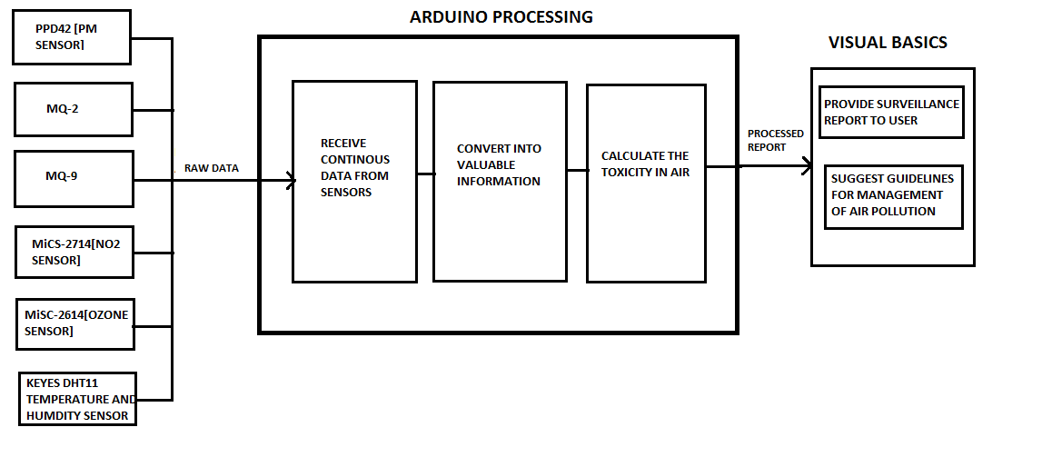



DEPENDENCIES/SHOW STOPPER
- https://youtu.be/5EeE6-xbF6s
- Knowledge on pollutants and its causative agents.
- Previous records on the surveillance area to compare the efficiency of PAVAN

